

LOW LEVEL DESIGN

Healthcare Analytics on Heart Disease Data

Revision Number: 1.3
Last Date of Revision:27/04/23

-Madhvendra Singh

Document Control

Date | Version | Description | Author
10/11/21 | 1.0 | Introduction , Problem | Madhvendra
 |  | statement
12/11/21 | 1.1 | Dataset information, | Madhvendra
 |  | Architecture, Description
23/11/21 | 1.3 | Final Revision | Madhvendra


Contents

Document Version Control
1. Introduction
1.1 what is Low Level Design Document
1.2 Scope
- Problem Statement

- Dataset Information

- Architecture
Introduction

1.1 What is Low Level Design Document ?

The goal of the Low-Level Design Document is to give the internal logic design of the actual program code for the Healthcare Analytics dashboard. LLDD describes the class diagrams with the methods and relations between classes and programs .

1.2 Scope ?

Low Level Design is a component –level design process that follows a step-by –step refinement process.The process can be used for designing data structures, required software architecture, source code and ultimately, performance algorithms. Overall, the data organization may be defined during requirement analysis and then refined during data design work.

Problem Statement

Health is real wealth in the pandemic time we all realized the brute effects of covid-19 on all irrespective of any status. You are required to analyze this health and medical data for better future preparation.

Find key metrics and factors and show the meaningful relationships between attributes.
Dataset Information

The fourteen features in Dataset we refer to are:

- Age: Age of different individuals in years

- Sex: Gender of the individuals [1=Male , 0=Female]

- Cp: Describes the Chest Pain experienced [0:aymptomatic , 1: Atypical Angina , 2: Non-Anginal Pain , 3:Typical Angina]

- Trestbps: Describes the Resting Blood Pressure in mm/hg

- Chol: Describes the Serum Cholesterol Level in mg/dl

- Fps: Describes the Fasting Blood Sugar > 120 mg/dl [0 = no, 1 = yes]

- Restecg: Describes the Resting ECG

[0: showing probable or definite left ventricular hypertrophy by Estes’ criteria, 1: normal, 2: having ST-T wave abnormality]
- Thalach: Describes the maximum heart rate achieved

- Exang: Refers to Exercise Induced Angina [1 = yes, 0 = no]

- Oldpeak: Refers to

ST depression induced by exercise relative to rest

- Slope: Describes the slope of the peak exercise ST segment [0: downsloping; 1: flat; 2: upsloping]
- Ca: [number of major vessels (0–3)

- Thal: A blood disorder called thalassemia

[1 = normal, 2 = fixed defect, 3 = reversible defect]

- Target: Heart Disease [0 = disease, 1 = no disease]
Architecture
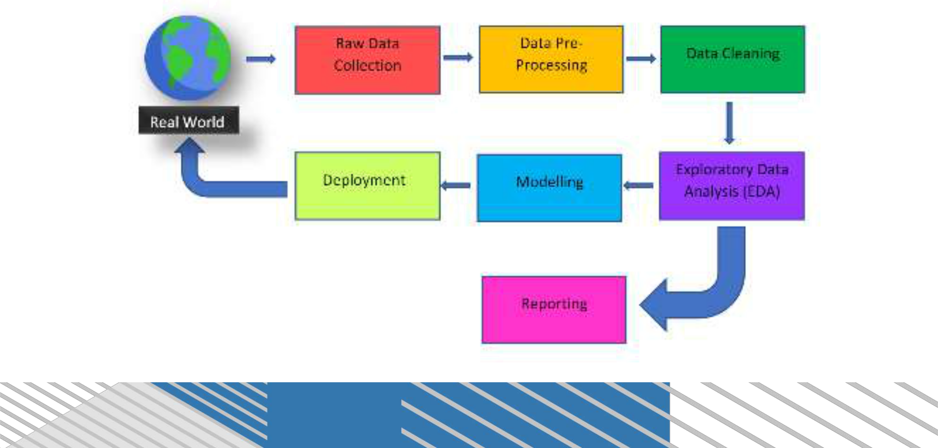
Architecture Description

The Dataset was taken from the iNeuron’s Provided Project Description Document , It is crucial to perform data pre-processing and data cleaning,

- Data Pre-processing includes:

- Handling Null/Missing Values b) Handling skewed data ▪ Data Cleaning Includes:

a) Removing Duplicate or irrelevant data b) Renaming required attributes
